**Climate change analysis with context to urban indicators**

Climate change datasets typically contain information related to various climatic variables such as temperature, precipitation, sea level rise, atmospheric components, and other weather phenomena. These datasets can be used for analysis to understand the patterns of climate change and their impacts on different regions around the world. To visualize this data in Python, we can use various Python libraries like Matplotlib, Seaborn, Plotly, and others to create different types of charts, graphs, and maps. Use the many types of plot such as line, ggplot, bar plot, step, etc. in this visualization use the two statics method such as skewness and kurtosis.

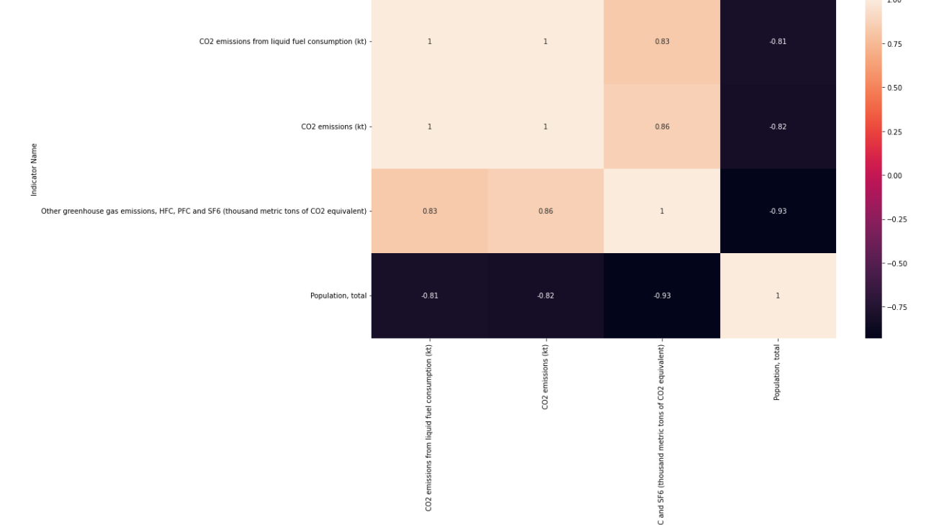

Figure Heat map for relation between indicator name

The output is a heatmap showing the correlation between the selected columns in the total pop data frame. The columns are represented by both the rows and columns of the heatmap. Each cell represents the correlation coefficient between the column in that row and the column in that column. The color of the cell represents the strength and direction of the correlation, with darker colors indicating a stronger positive correlation and lighter colors indicating weaker or negative correlations. also see that there is a very weak correlation between "Population, total" and the other three greenhouse gas emission columns. This indicates that population size may not be as strongly related to greenhouse gas emissions as the other factors.

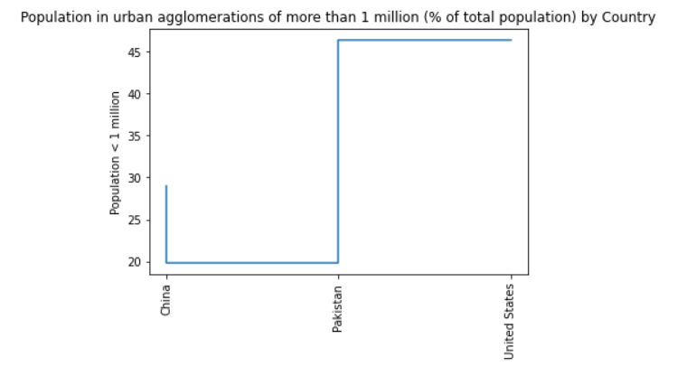

Figure population in urban agglomerations

The resulting visualization is a step plot that shows the percentage of population living in urban agglomerations of more than 1 million for each selected country in the year 2020. The x-axis displays the names of the countries and the y-axis represents the percentage of population living in these urban areas. This visualization helps to compare the trend across countries and identify if any country stands out with high or low percentage of population living in such areas.

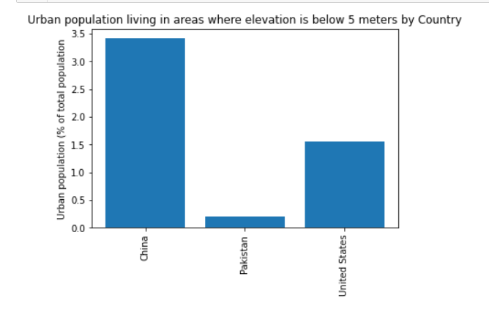

Figure urban population living in these areas

The resulting visualization is a bar chart that shows the percentage of the urban population living in areas where elevation is below 5 meters for each selected country in the year 2000. The x-axis displays the names of the countries and the y-axis represents the percentage of urban population living in areas below 5 meters. This visualization helps understand the vulnerability of different countries to rising sea levels due to climate change, as areas with lower elevation are more prone to flooding risks. By comparing the urban population living in such areas for each country, we can get an idea of which countries are more vulnerable to climate change-related hazards.

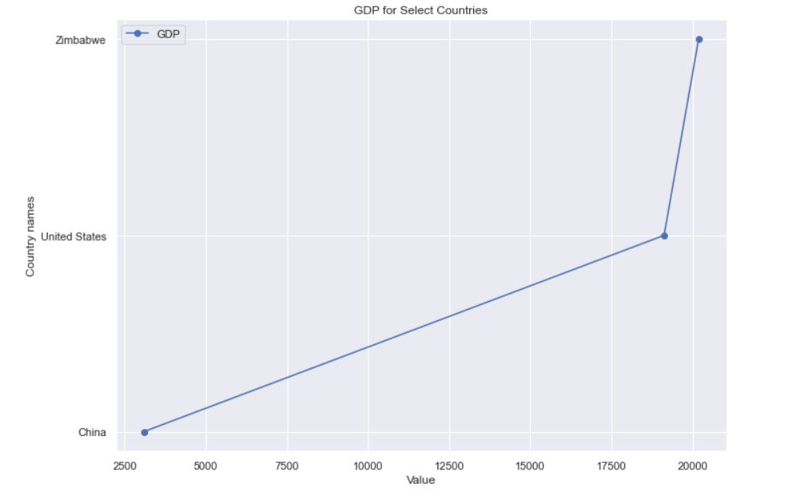

Figure GDP for selected countries

The resulting visualization is a line chart that shows the GDP values for selected countries on the y-axis, with the names of the countries on the x-axis. Each value is represented by a data point marked by a circle. This visualization can help us compare the relative economic growth of different countries over time. Overall, this is a basic visualization that only plots the GDP value and there are many ways to enhance it further by customizing the plot settings or visualizing other indicators alongside GDP for better comparison.

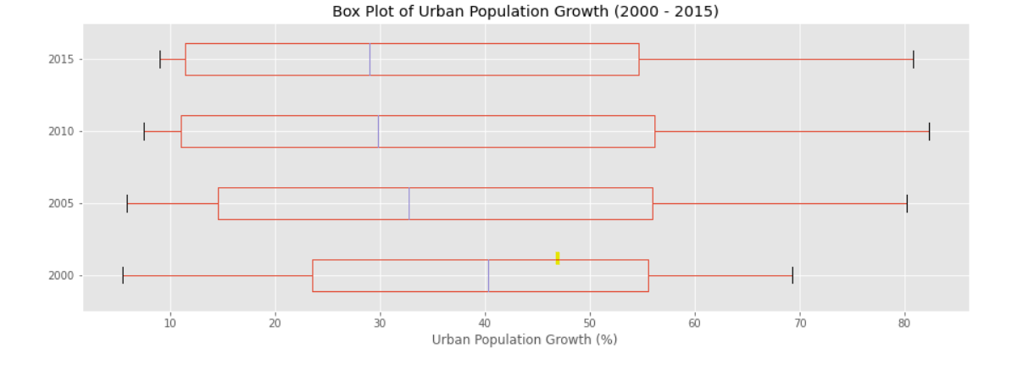

Figure box plot for urban population growth

The resulting visualization is a box plot that shows the distribution of the urban population growth for the top 10 countries for each year from 2000 to 2015. Each year corresponds to a separate box in the plot with horizontal lines representing different quartiles of data distribution. The lines inside the boxes represent median values whereas each point outside the whiskers (horizontal lines) represents an outlier. This visualization can help us compare the distribution of urban population growth among different countries and assess factors like urbanization, economic conditions, or demographics in different regions. The styling of the plot is clean and minimalistic, thanks to the ggplot style used.

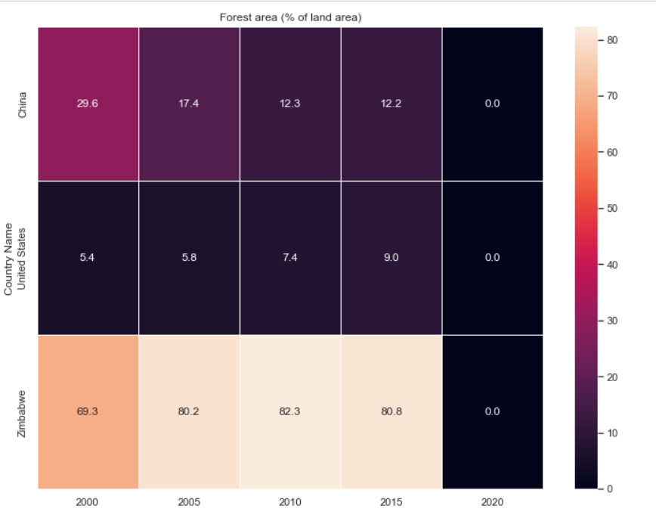

Figure Heat map for relation

The resulting visualization is a heatmap that shows the percentage of forest area as a proportion of total land area across different years (2000-2020). The horizontal axis shows the year while the vertical axis shows a general trend for the countries in the dataset. Dark colors indicate higher values, and light colors indicate lower values. The annotation inside each box shows the percentage of forest area as a proportion of total area, with one decimal point. This visualization can help us compare the changes in forest cover among different countries throughout the years or identify which countries are experiencing rapid deforestation over time. The size of the plot, color scheme, and grid lines make it easy to visualize and track changes between years, and the annotations make it easy to identify exact values.